1. Dataset plot
In this problem, we use the fetch_20newsgroups dataset from sklearn package to plot the number of training documents per class.
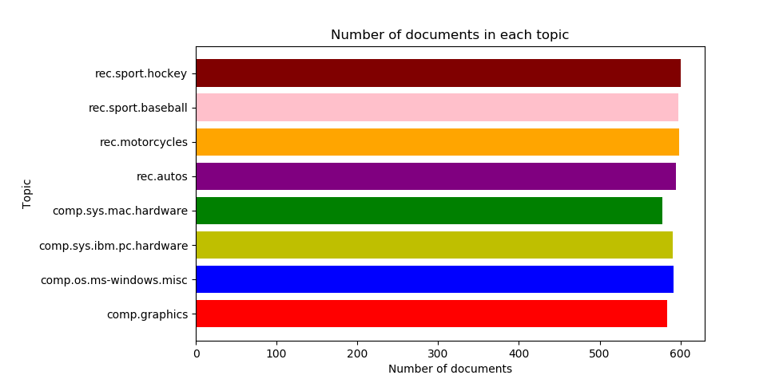
From the figure above, we could see that the data set is already balanced and in every class the number of documents is almost equivalent.

2. Create TF*IDF vector representation

A popular numerical statistic to capture the importance of a word is TFxIDF metric. This measure takes into account the words in the document. The discriminating words will most likely be those that are specialized terms describing different types of accessories and hence will occur in fewer documents.
In this problem, we need to convert the documents of 8 classes into numerical feature vectors. Firstly, we use ‘snowball’ to remove morphological affixes from words. After that, we remove all punctuation, all symbols and non-ascii characters. We used TfidfTransformer to calculate TFIDF, where tf(t, d) represents the frequency of term t in document d, and inverse document frequency is defined as: idf(t) = log [ n / df(t)] + 1 and df(t) is the document frequency; the document frequency is the number of documents that contain the term t.

Token shape: (4732, 21795) [min_df = 2, enable_stopword = True, enable_stem = True]
TFxIDF shape: (4732, 21795) [min_df = 2, enable_stopword = True, enable_stem = True]
[min_df = 2] Number of terms: 21795
Token shape: (4732, 8818) [min_df = 5, enable_stopword = True, enable_stem = True]
TFxIDF shape: (4732, 8818) [min_df = 5, enable_stopword = True, enable_stem = True]
[min_df = 5] Number of terms: 8818

3. Calculate the TF*ICF
In order to quantify how significant a word is to a class, we calculate TFxICF. It is the same as TFxIDF, except that a class sits in place of a document; that is for a term t and a class c. And we need to find the 10 most significant terms in each of the 4 classes with respect to TFICF measure.

comp.sys.ibm.pc.hardware [u'scsi', u'drive', u'edu', u'ide', u'line', u'use', u'com', u'subject', u'organization', u'controller']

comp.sys.mac.hardware [u'edu', u'line', u'mac', u'subject', u'organization', u'apple', u'use', u'quadra', u'scsi', u'problem']

misc.forsale [u'edu', u'line', u'sale', u'subject', u'organization', u'new', u'post', u'com', u'university', u'offer']

soc.religion.christian [u'god', u'edu', u'christian', u'jesus', u'say', u'church', u'subject', u'people', u'line', u'know']

4. Reduce dimension
In this problem, we need to transform the data’s dimensional into a lower dimensional space. We use Latent Semantic Indexing (LSI) and NMF to lower the space into 50. As to LSI, we used the SVD decomposition to obtain left and right singular vectors and then get a lower space.

Token shape: (4732, 24849) [min_df = 2, enable_stopword = True, enable_stem = True]

TFxIDF shape: (4732, 24849) [min_df = 2, enable_stopword = True, enable_stem = True]

Shape of feature vec after LSI: (4732, 50)

Shape of feature vec after NMF: (4732, 50)

5. SVM
In next parts, we need to classify the documents into two categories ‘‘Computer Technology’ vs ‘Recreational Activity’. We need to combine documents of sub-classes of each class to form the set of documents for each class. And we need to assess the model by precision, recall and ROC curve.
In this part, based on LSI and NMF, we used SVM to make classification.

The goal is to figure out: whether it is worth keeping so many "rare" terms?

When min_df = 2
1) Hard- SVM with LSI
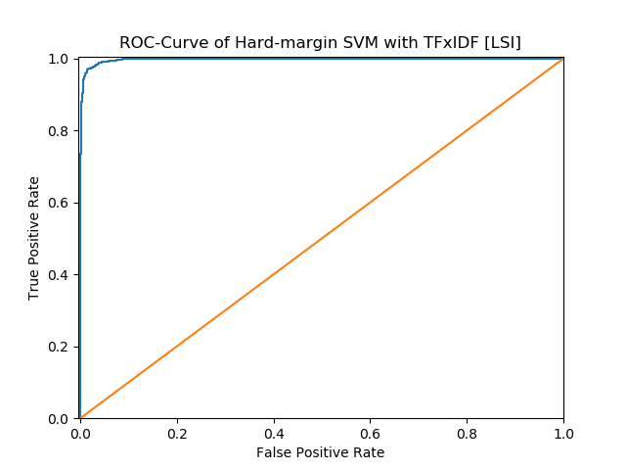

 | Precision | Recall | Accuracy
Computer technology | 0.9938 | 0.9295 | 0.9622
Recreational activity | 0.9349 | 0.9943 | 0.9622
Average | 0.9619 | 0.9644 | 0.9622

 | TP | FP | FN | TN
Computer technology | 1450 | 9 | 110 | 1581
Recreational activity | 1581 | 110 | 9 | 1450

We set computer technology as positive and recreational activity as negative to construct the confusion matrix as follow:

 | Ground Truth | Ground False
Predicted positive | 1450 | 9
Predicted negative | 110 | 1581

2) Hard- SVM with NMF
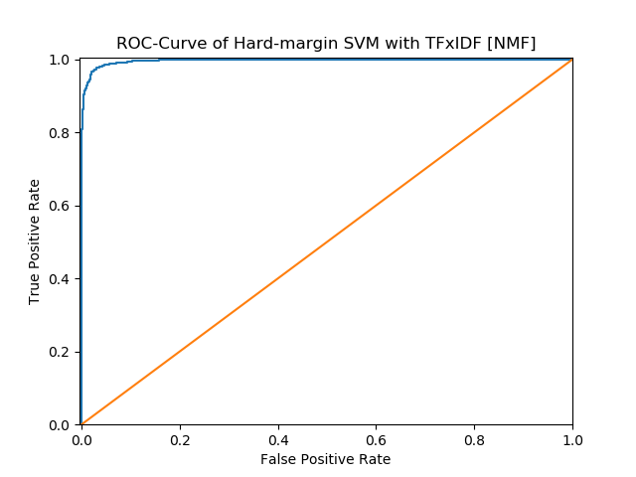

 | Precision | Recall | Accuracy
Computer technology | 0.9916 | 0.9090 | 0.9511
Recreational activity | 0.9174 | 0.9925 | 0.9511
Average | 0.9507 | 0.9545 | 0.9511

 | TP | FP | FN | TN
Computer technology | 1418 | 12 | 142 | 1578
Recreational activity | 1578 | 142 | 12 | 1418

We set computer technology as positive and recreational activity as negative to construct the confusion matrix as follow:
 | Ground Truth | Ground False
Predicted positive | 1418 | 12
Predicted negative | 142 | 1578

3) Soft- SVM with LSI
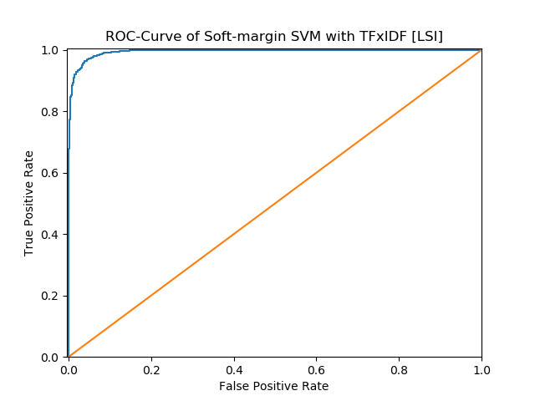

 | Precision | Recall | Accuracy
Computer technology | 0.9922 | 0.8917 | 0.9429
Recreational activity | 0.9033 | 0.9931 | 0.9429
Average | 0.9424 | 0.9477 | 0.9429

 | TP | FP | FN | TN
Computer technology | 1391 | 11 | 169 | 1579
Recreational activity | 1579 | 169 | 11 | 1391
We set computer technology as positive and recreational activity as negative to construct the confusion matrix as follow:

 | Ground Truth | Ground False
Predicted positive | 1391 | 11
Predicted negative | 169 | 1579
4) Soft- SVM with NMF
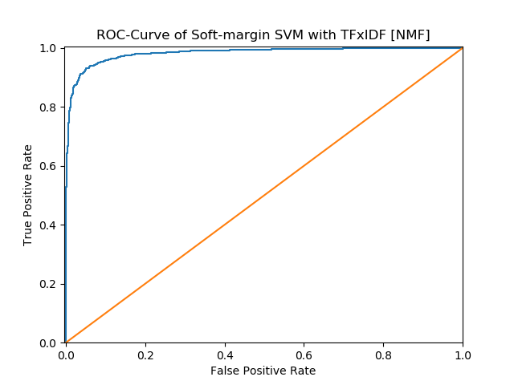

 | Precision | Recall | Accuracy
Computer technology | 1.0000 | 0.0410 | 0.5251
Recreational activity | 0.5152 | 1.0000 | 0.5251
Average | 0.5205 | 0.7576 | 0.5251

 | TP | FP | FN | TN
Computer technology | 64 | 0 | 1496 | 1590
Recreational activity | 1590 | 1496 | 0 | 64
We set computer technology as positive and recreational activity as negative to construct the confusion matrix as follow:
 | Ground Truth | Ground False
Predicted positive | 64 | 0
Predicted negative | 1496 | 1590
When min_df=5
- Hard-SVM with LSI
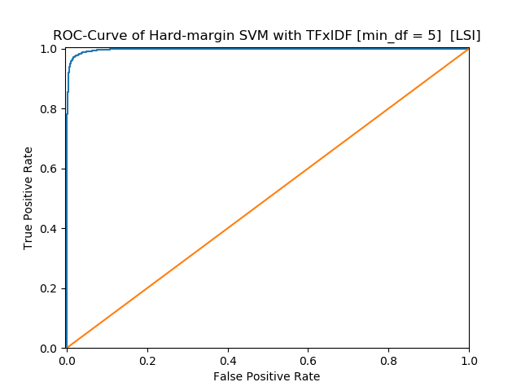

 | Precision | Recall | Accuracy
Computer technology | 0.9666 | 0.9827 | 0.9746
Recreational activity | 0.9827 | 0.9667 | 0.9746
Average | 0.9747 | 0.9747 | 0.9746

 | TP | FP | FN | TN
Computer technology | 1533 | 53 | 27 | 1537
Recreational activity | 1537 | 27 | 53 | 1533
We set computer technology as positive and recreational activity as negative to construct the confusion matrix as follow:
 | Ground Truth | Ground False
Predicted positive | 1533 | 53
Predicted negative | 27 | 1537

- Hard-SVM with NMF
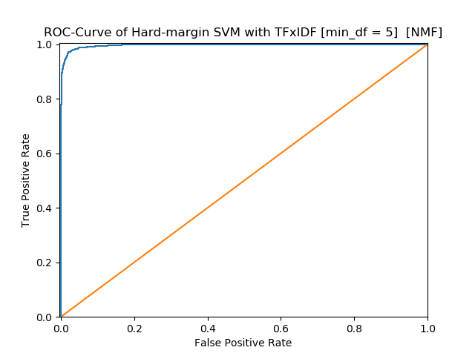

 | Precision | Recall | Accuracy
Computer technology | 0.9910 | 0.9173 | 0.9549
Recreational activity | 0.9244 | 0.9918 | 0.9549
Average | 0.9546 | 0.9577 | 0.9549

 | TP | FP | FN | TN
Computer technology | 1431 | 13 | 129 | 1577
Recreational activity | 1577 | 129 | 13 | 1431
We set computer technology as positive and recreational activity as negative to construct the confusion matrix as follow:
 | Ground Truth | Ground False
Predicted positive | 1431 | 13
Predicted negative | 129 | 1577

- Soft-SVM with LSI
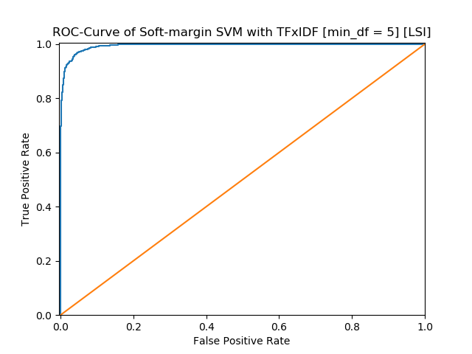

 | Precision | Recall | Accuracy
Computer technology | 0.9908 | 0.8981 | 0.9454
Recreational activity | 0.9084 | 0.9918 | 0.9454
Average | 0.9450 | 0.9496 | 0.9454

 | TP | FP | FN | TN
Computer technology | 1401 | 13 | 159 | 1577
Recreational activity | 1577 | 159 | 13 | 1401
We set computer technology as positive and recreational activity as negative to construct the confusion matrix as follow:
 | Ground Truth | Ground False
Predicted positive | 1401 | 13
Predicted negative | 159 | 1577
- Soft-SVM with NMF
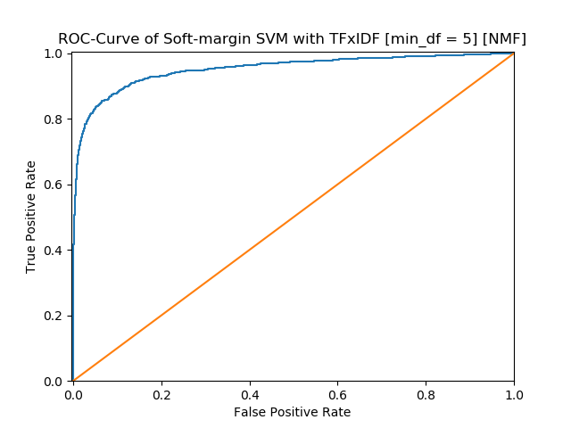

 | Precision | Recall | Accuracy
Computer technology | 0.9576 | 0.3910 | 0.6898
Recreational activity | 0.6220 | 0.9830 | 0.6898
Average | 0.6870 | 0.7898 | 0.6898

 | TP | FP | FN | TN
Computer technology | 610 | 27 | 950 | 1563
Recreational activity | 1563 | 950 | 27 | 610
We set computer technology as positive and recreational activity as negative to construct the confusion matrix as follow:
 | Ground Truth | Ground False
Predicted positive | 610 | 27
Predicted negative | 950 | 1563

6. In this part, we use 5-fold cross-validation to find the parameter γ and report the confusion matrix and accuracy,recall and precision.
2
[gamma = 0.001] 5-Fold Average Accuracy: 0.94421304
[gamma = 0.01] 5-Fold Average Accuracy: 0.96745837
[gamma = 0.1] 5-Fold Average Accuracy: 0.96999537
[gamma = 1.0] 5-Fold Average Accuracy: 0.97591124
[gamma = 10] 5-Fold Average Accuracy: 0.97654459
[gamma = 100] 5-Fold Average Accuracy: 0.97569870
[gamma = 1000] 5-Fold Average Accuracy: 0.97379774
Best Accuracy is 0.97654459 when gamma = 10

SVM with TFxIDF [LSI]
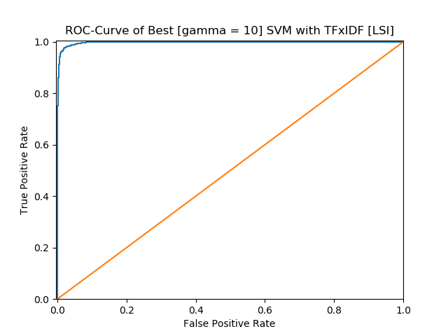

 | Precision | Recall | Accuracy
Computer technology | 0.9818 | 0.9679 | 0.9752
Recreational activity | 0.9690 | 0.9824 | 0.9752
Average | 0.9752 | 0.9754 | 0.9752

 | TP | FP | FN | TN
Computer technology | 1510 | 28 | 50 | 1562
Recreational activity | 1562 | 50 | 28 | 1510
We set computer technology as positive and recreational activity as negative to construct the confusion matrix as follow:
 | Ground Truth | Ground False
Predicted positive | 1510 | 28
Predicted negative | 50 | 1562

SVM with TFxIDF [NMF]

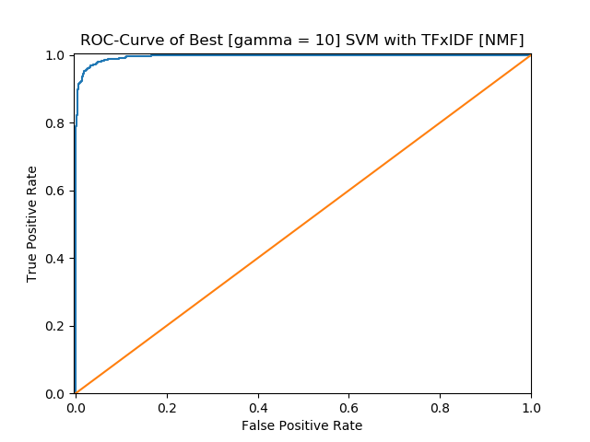

 | Precision | Recall | Accuracy
Computer technology | 0.9738 | 0.9538 | 0.9644
Recreational activity | 0.9556 | 0.9748 | 0.9644
Average | 0.9643 | 0.9647 | 0.9644

 | TP | FP | FN | TN
Computer technology | 1488 | 40 | 72 | 1550
Recreational activity | 1550 | 72 | 40 | 1488
We set computer technology as positive and recreational activity as negative to construct the confusion matrix as follow:
 | Ground Truth | Ground False
Predicted positive | 1488 | 40
Predicted negative | 72 | 1550

5

[gamma = 0.001] 5-Fold Average Accuracy: 0.94695967
[gamma = 0.01] 5-Fold Average Accuracy: 0.96640173
[gamma = 0.1] 5-Fold Average Accuracy: 0.97020656
[gamma = 1.0] 5-Fold Average Accuracy: 0.97506535
[gamma = 10] 5-Fold Average Accuracy: 0.97612198
[gamma = 100] 5-Fold Average Accuracy: 0.97548840
[gamma = 1000] 5-Fold Average Accuracy: 0.95838086
Best Accuracy is 0.97612198 when gamma = 10
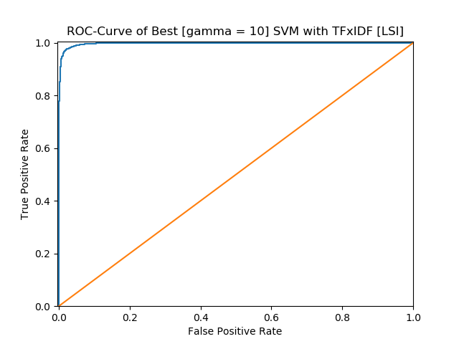

************************************************************
* Best [gamma = 10] SVM with TFxIDF [LSI]
************************************************************
Precision Recall Accuracy
Computer technology 0.9812 0.9679 0.9749
Recreational activity 0.9690 0.9818 0.9749
Average 0.9749 0.9751 0.9749
------------------------------------------------------------
TP FP FN TN
Computer technology 1510 29 50 1561
Recreational activity 1561 50 29 1510

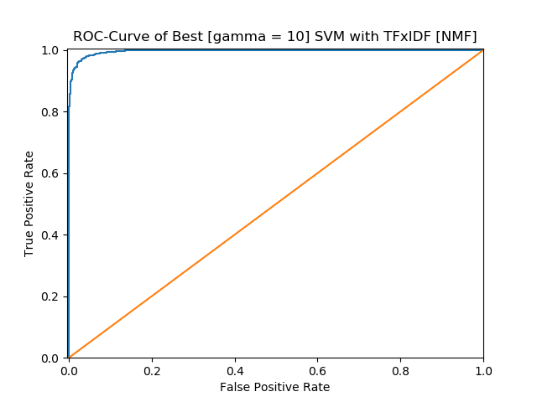

************************************************************
* Best [gamma = 10] SVM with TFxIDF [NMF]
************************************************************
Precision Recall Accuracy
Computer technology 0.9784 0.9564 0.9679
Recreational activity 0.9582 0.9792 0.9679
Average 0.9678 0.9683 0.9679
------------------------------------------------------------
TP FP FN TN
Computer technology 1492 33 68 1557
Recreational activity 1557 68 33 1492
------------------------------------------------------------

7. Next, we use naïve Bayes algorithm for the same classification task.
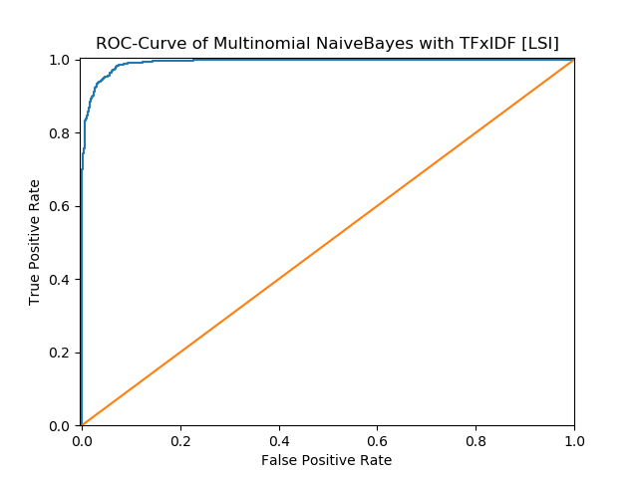

 | Precision | Recall | Accuracy
Computer technology | 0.9927 | 0.8718 | 0.9333
Recreational activity | 0.8876 | 0.9937 | 0.9333
Average | 0.9328 | 0.9402 | 0.9333

 | TP | FP | FN | TN
Computer technology | 1360 | 10 | 200 | 1580
Recreational activity | 1580 | 200 | 10 | 1360
We set computer technology as positive and recreational activity as negative to construct the confusion matrix as follow:
 | Ground Truth | Ground False
Predicted positive | 1360 | 10
Predicted negative | 200 | 1580

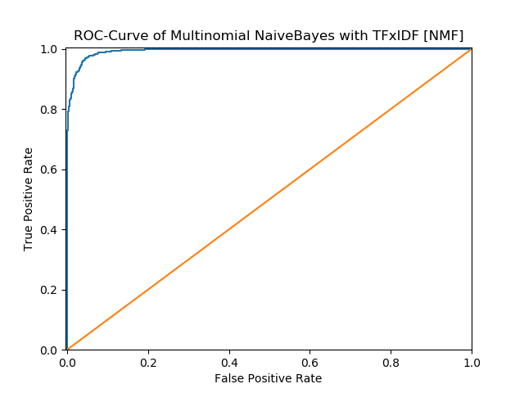

 | Precision | Recall | Accuracy
Computer technology | 0.9773 | 0.9397 | 0.9594
Recreational activity | 0.9430 | 0.9786 | 0.9594
Average | 0.9592 | 0.9602 | 0.9594

 | TP | FP | FN | TN
Computer technology | 1466 | 34 | 94 | 1556
Recreational activity | 1556 | 94 | 34 | 1466
We set computer technology as positive and recreational activity as negative to construct the confusion matrix as follow:
 | Ground Truth | Ground False
Predicted positive | 1466 | 34
Predicted negative | 94 | 1556

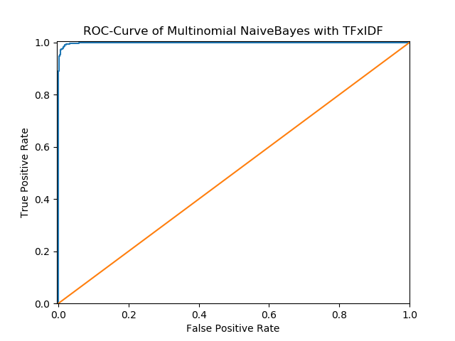

 | Precision | Recall | Accuracy
Computer technology | 0.9890 | 0.9814 | 0.9854
Recreational activity | 0.9819 | 0.9893 | 0.9854
Average | 0.9854 | 0.9855 | 0.9854

 | TP | FP | FN | TN
Computer technology | 1531 | 17 | 29 | 1573
Recreational activity | 1573 | 29 | 17 | 1531

We set computer technology as positive and recreational activity as negative to construct the confusion matrix as follow:
 | Ground Truth | Ground False
Predicted positive | 1531 | 17
Predicted negative | 29 | 1573

5
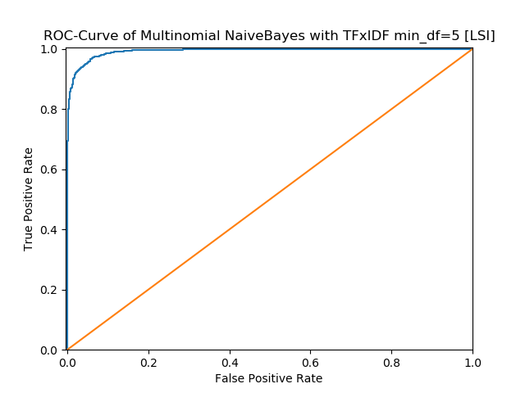

************************************************************
* Multinomial NaiveBayes with TFxIDF min_df=5 [LSI]
************************************************************
Precision Recall Accuracy
Computer technology 0.9967 0.7686 0.8841
Recreational activity 0.8146 0.9975 0.8841
Average 0.8830 0.9056 0.8841
------------------------------------------------------------
TP FP FN TN
Computer technology 1199 4 361 1586
Recreational activity 1586 361 4 1199

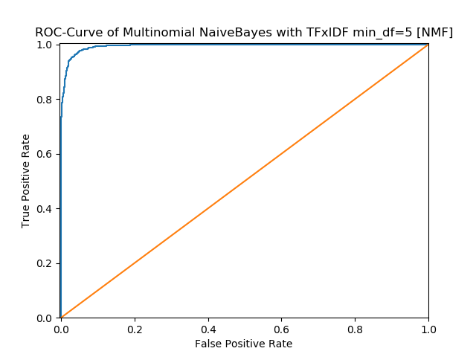

************************************************************
* Multinomial NaiveBayes with TFxIDF min_df=5 [NMF]
************************************************************
Precision Recall Accuracy
Computer technology 0.9811 0.9333 0.9581
Recreational activity 0.9376 0.9824 0.9581
Average 0.9579 0.9594 0.9581
------------------------------------------------------------
TP FP FN TN
Computer technology 1456 28 104 1562
Recreational activity 1562 104 28 1456

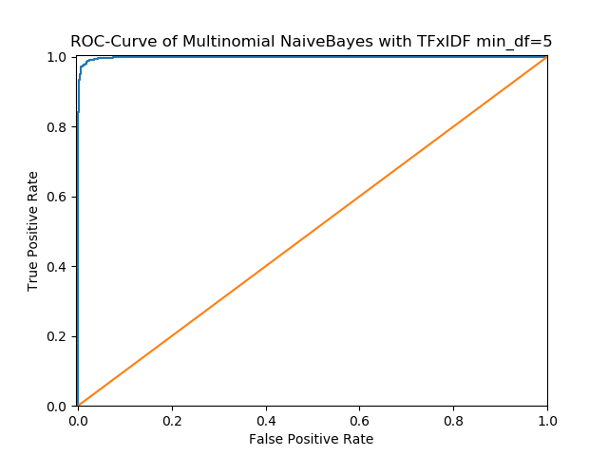

************************************************************
* Multinomial NaiveBayes with TFxIDF min_df=5
************************************************************
Precision Recall Accuracy
Computer technology 0.9771 0.9840 0.9806
Recreational activity 0.9842 0.9774 0.9806
Average 0.9807 0.9806 0.9806
------------------------------------------------------------
TP FP FN TN
Computer technology 1535 36 25 1554
Recreational activity 1554 25 36 1535
------------------------------------------------------------

8. Repeat the same task with the logistic regression classifier, and plot the ROC curve.
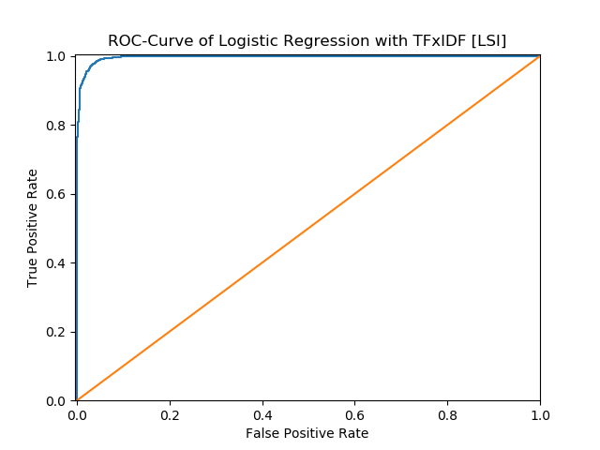

 | Precision | Recall | Accuracy
Computer technology | 0.9804 | 0.9603 | 0.9708
Recreational activity | 0.9618 | 0.9811 | 0.9708
Average | 0.9707 | 0.9711 | 0.9708

 | TP | FP | FN | TN
Computer technology | 1498 | 30 | 62 | 1560
Recreational activity | 1560 | 62 | 30 | 1498

We set computer technology as positive and recreational activity as negative to construct the confusion matrix as follow:
 | Ground Truth | Ground False
Predicted positive | 1498 | 30
Predicted negative | 62 | 1560

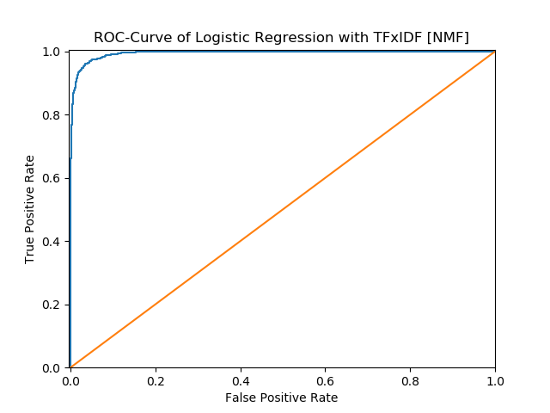

 | Precision | Recall | Accuracy
Computer technology | 0.9657 | 0.9551 | 0.9610
Recreational activity | 0.9564 | 0.9667 | 0.9610
Average | 0.9609 | 0.9610 | 0.9610

 | TP | FP | FN | TN
Computer technology | 1490 | 53 | 70 | 1573
Recreational activity | 1537 | 70 | 53 | 1490

We set computer technology as positive and recreational activity as negative to construct the confusion matrix as follow:
 | Ground Truth | Ground False
Predicted positive | 1490 | 53
Predicted negative | 70 | 1537

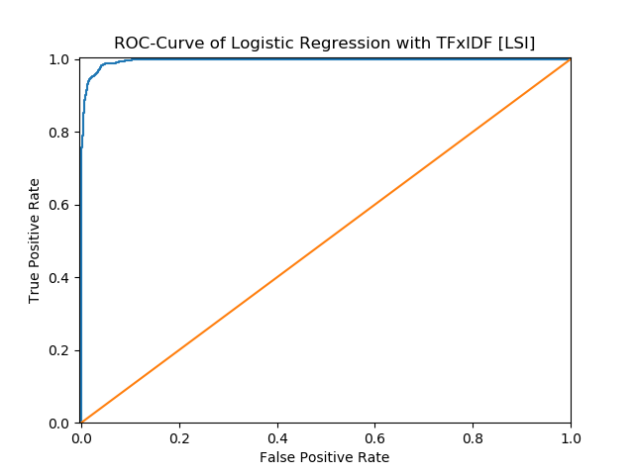

************************************************************
* Logistic Regression with TFxIDF [LSI]
************************************************************
Precision Recall Accuracy
Computer technology 0.9784 0.9596 0.9695
Recreational activity 0.9611 0.9792 0.9695
Average 0.9694 0.9698 0.9695
------------------------------------------------------------
TP FP FN TN
Computer technology 1497 33 63 1557
Recreational activity 1557 63 33 1497

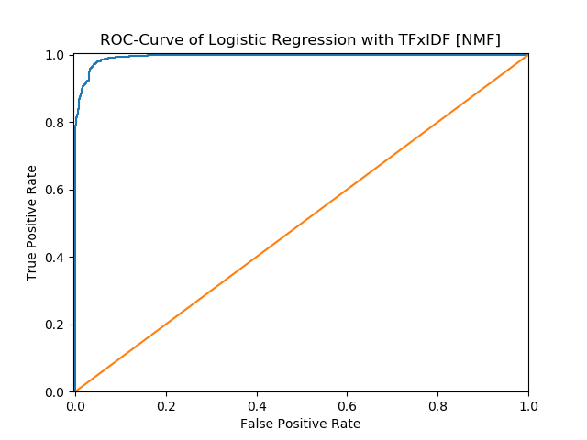

************************************************************
* Logistic Regression with TFxIDF [NMF]
************************************************************
Precision Recall Accuracy
Computer technology 0.9683 0.9603 0.9648
Recreational activity 0.9613 0.9692 0.9648
Average 0.9647 0.9648 0.9648
------------------------------------------------------------
TP FP FN TN
Computer technology 1498 49 62 1541
Recreational activity 1541 62 49 1498
------------------------------------------------------------

9. Now, by adding a regularization term to the optimization objective. Try both l 1 and l 2 norm regularizations and sweep through different regularization coefficients, ranging from very small ones to large ones. How does the regularization parameter affect the test error? How are the coefficients of the fitted hyperplane affected? Why might one be interested in each type of
regularization?
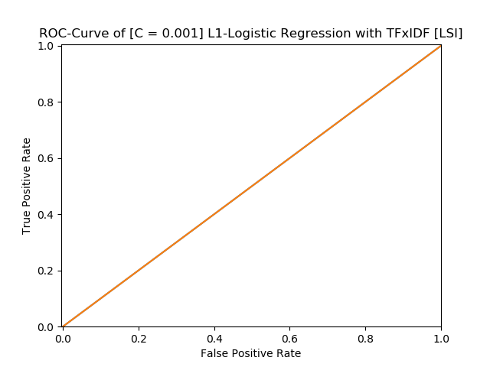

************************************************************
* [C = 0.001] L1-Logistic Regression with TFxIDF [LSI]
************************************************************
Precision Recall Accuracy
Computer technology 0.4952 1.0000 0.4952
Recreational activity 0.0000 0.0000 0.4952
Average 0.5000 0.2476 0.4952
------------------------------------------------------------
TP FP FN TN
Computer technology 1560 1590 0 0
Recreational activity 0 0 1590 1560
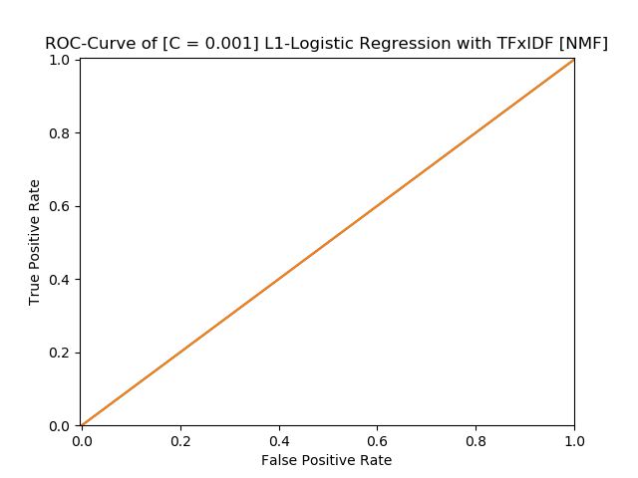

************************************************************
* [C = 0.001] L1-Logistic Regression with TFxIDF [NMF]
************************************************************
Precision Recall Accuracy
Computer technology 0.4952 1.0000 0.4952
Recreational activity 0.0000 0.0000 0.4952
Average 0.5000 0.2476 0.4952
------------------------------------------------------------
TP FP FN TN
Computer technology 1560 1590 0 0
Recreational activity 0 0 1590 1560
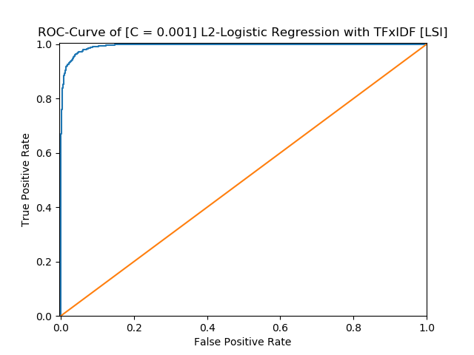

************************************************************
* [C = 0.001] L2-Logistic Regression with TFxIDF [LSI]
************************************************************
Precision Recall Accuracy
Computer technology 1.0000 0.5474 0.7759
Recreational activity 0.6925 1.0000 0.7759
Average 0.7737 0.8463 0.7759
------------------------------------------------------------
TP FP FN TN
Computer technology 854 0 706 1590
Recreational activity 1590 706 0 854

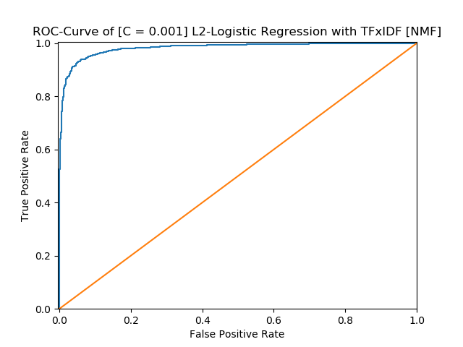

************************************************************
* [C = 0.001] L2-Logistic Regression with TFxIDF [NMF]
************************************************************
Precision Recall Accuracy
Computer technology 0.0000 0.0000 0.5048
Recreational activity 0.5048 1.0000 0.5048
Average 0.5000 0.2524 0.5048
------------------------------------------------------------
TP FP FN TN
Computer technology 0 0 1560 1590
Recreational activity 1590 1560 0 0

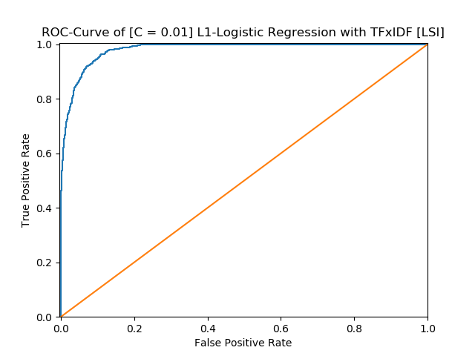

************************************************************
* [C = 0.01] L1-Logistic Regression with TFxIDF [LSI]
************************************************************
Precision Recall Accuracy
Computer technology 0.9256 0.9173 0.9225
Recreational activity 0.9196 0.9277 0.9225
Average 0.9225 0.9226 0.9225
------------------------------------------------------------
TP FP FN TN
Computer technology 1431 115 129 1475
Recreational activity 1475 129 115 1431

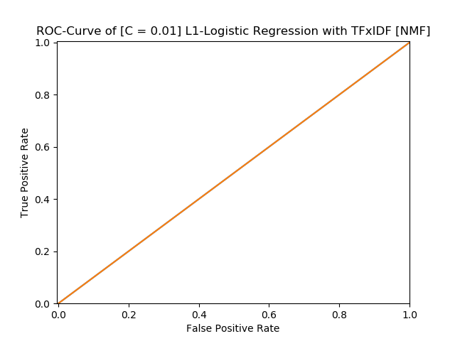

************************************************************
* [C = 0.01] L1-Logistic Regression with TFxIDF [NMF]
************************************************************
Precision Recall Accuracy
Computer technology 0.4952 1.0000 0.4952
Recreational activity 0.0000 0.0000 0.4952
Average 0.5000 0.2476 0.4952
------------------------------------------------------------
TP FP FN TN
Computer technology 1560 1590 0 0
Recreational activity 0 0 1590 1560

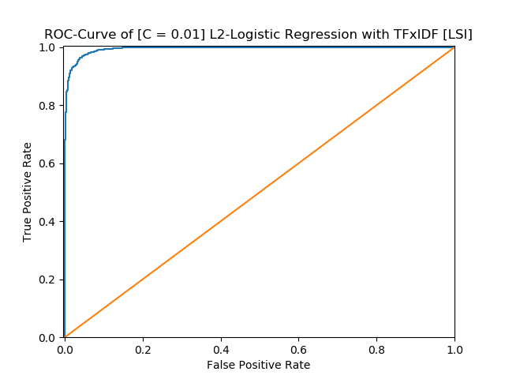

************************************************************
* [C = 0.01] L2-Logistic Regression with TFxIDF [LSI]
************************************************************
Precision Recall Accuracy
Computer technology 0.9909 0.9038 0.9483
Recreational activity 0.9131 0.9918 0.9483
Average 0.9478 0.9520 0.9483
------------------------------------------------------------
TP FP FN TN
Computer technology 1410 13 150 1577
Recreational activity 1577 150 13 1410

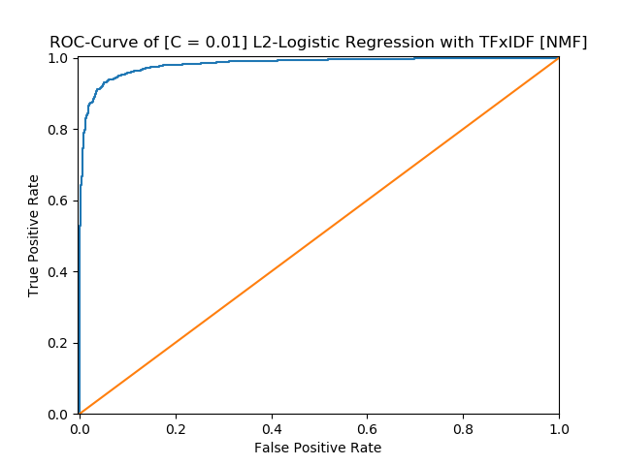

************************************************************
* [C = 0.01] L2-Logistic Regression with TFxIDF [NMF]
************************************************************
Precision Recall Accuracy
Computer technology 1.0000 0.0635 0.5362
Recreational activity 0.5211 1.0000 0.5362
Average 0.5317 0.7606 0.5362
------------------------------------------------------------
TP FP FN TN
Computer technology 99 0 1461 1590
Recreational activity 1590 1461 0 99

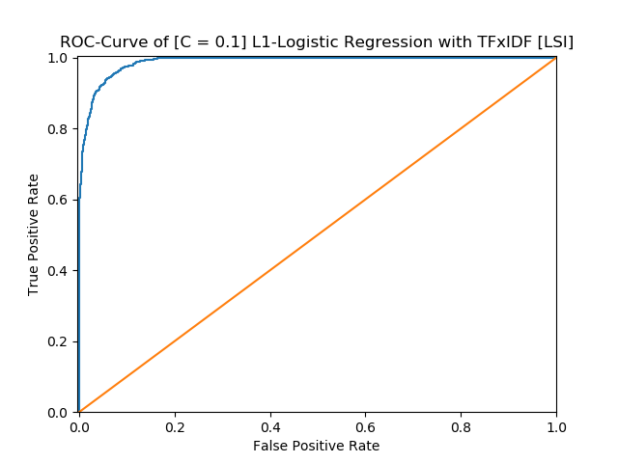

************************************************************
* [C = 0.1] L1-Logistic Regression with TFxIDF [LSI]
************************************************************
Precision Recall Accuracy
Computer technology 0.9555 0.9231 0.9406
Recreational activity 0.9270 0.9579 0.9406
Average 0.9405 0.9413 0.9406
------------------------------------------------------------
TP FP FN TN
Computer technology 1440 67 120 1523
Recreational activity 1523 120 67 1440

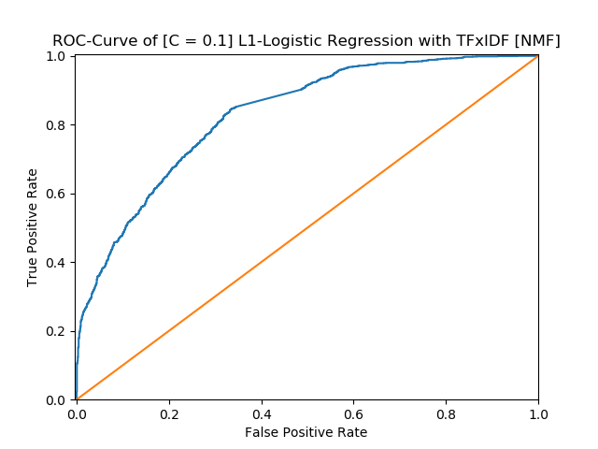

************************************************************
* [C = 0.1] L1-Logistic Regression with TFxIDF [NMF]
************************************************************
Precision Recall Accuracy
Computer technology 0.8462 0.5045 0.7092
Recreational activity 0.6518 0.9101 0.7092
Average 0.7073 0.7490 0.7092
------------------------------------------------------------
TP FP FN TN
Computer technology 787 143 773 1447
Recreational activity 1447 773 143 787

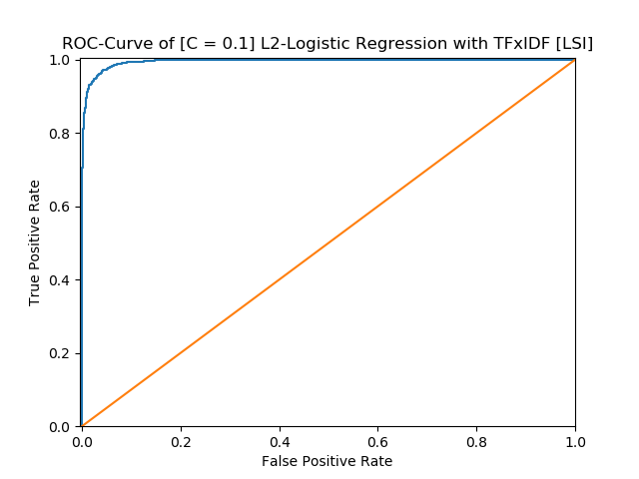

************************************************************
* [C = 0.1] L2-Logistic Regression with TFxIDF [LSI]
************************************************************
Precision Recall Accuracy
Computer technology 0.9769 0.9468 0.9625
Recreational activity 0.9493 0.9780 0.9625
Average 0.9624 0.9631 0.9625
------------------------------------------------------------
TP FP FN TN
Computer technology 1477 35 83 1555
Recreational activity 1555 83 35 1477

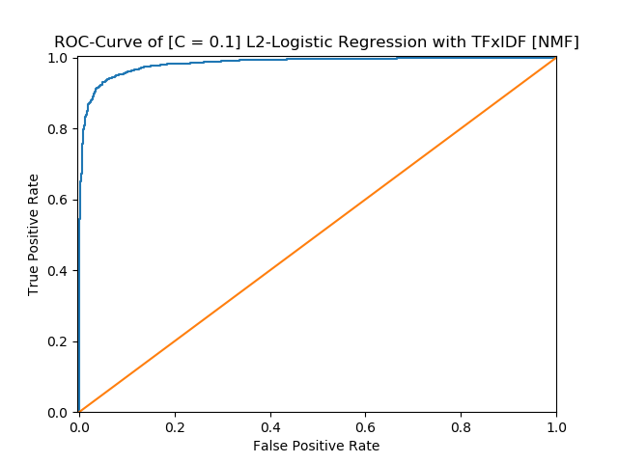

************************************************************
* [C = 0.1] L2-Logistic Regression with TFxIDF [NMF]
************************************************************
Precision Recall Accuracy
Computer technology 0.9784 0.8128 0.8984
Recreational activity 0.8425 0.9824 0.8984
Average 0.8976 0.9104 0.8984
------------------------------------------------------------
TP FP FN TN
Computer technology 1268 28 292 1562
Recreational activity 1562 292 28 1268

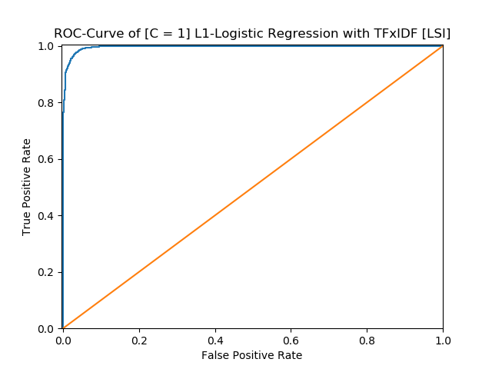

************************************************************
* [C = 1] L1-Logistic Regression with TFxIDF [LSI]
************************************************************
Precision Recall Accuracy
Computer technology 0.9804 0.9603 0.9708
Recreational activity 0.9618 0.9811 0.9708
Average 0.9707 0.9711 0.9708
------------------------------------------------------------
TP FP FN TN
Computer technology 1498 30 62 1560
Recreational activity 1560 62 30 1498

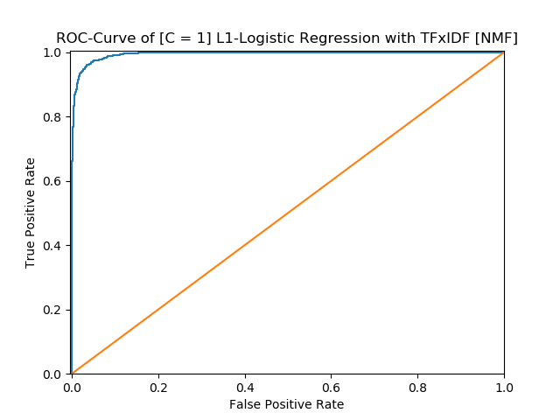

************************************************************
* [C = 1] L1-Logistic Regression with TFxIDF [NMF]
************************************************************
Precision Recall Accuracy
Computer technology 0.9657 0.9551 0.9610
Recreational activity 0.9564 0.9667 0.9610
Average 0.9609 0.9610 0.9610
------------------------------------------------------------
TP FP FN TN
Computer technology 1490 53 70 1537
Recreational activity 1537 70 53 1490

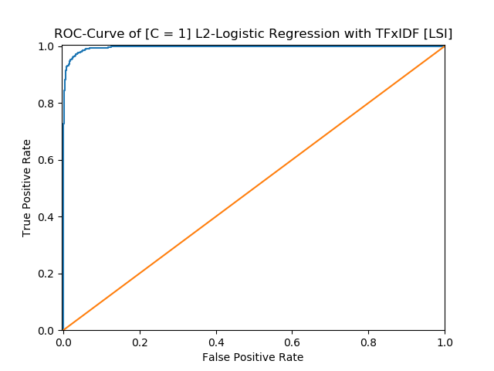

************************************************************
* [C = 1] L2-Logistic Regression with TFxIDF [LSI]
************************************************************
Precision Recall Accuracy
Computer technology 0.9764 0.9564 0.9670
Recreational activity 0.9581 0.9774 0.9670
Average 0.9669 0.9673 0.9670
------------------------------------------------------------
TP FP FN TN
Computer technology 1492 36 68 1554
Recreational activity 1554 68 36 1492

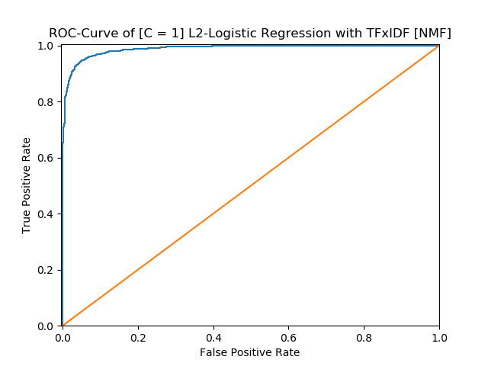

************************************************************
* [C = 1] L2-Logistic Regression with TFxIDF [NMF]
************************************************************
Precision Recall Accuracy
Computer technology 0.9587 0.9224 0.9419
Recreational activity 0.9266 0.9610 0.9419
Average 0.9417 0.9427 0.9419
------------------------------------------------------------
TP FP FN TN
Computer technology 1439 62 121 1528
Recreational activity 1528 121 62 1439

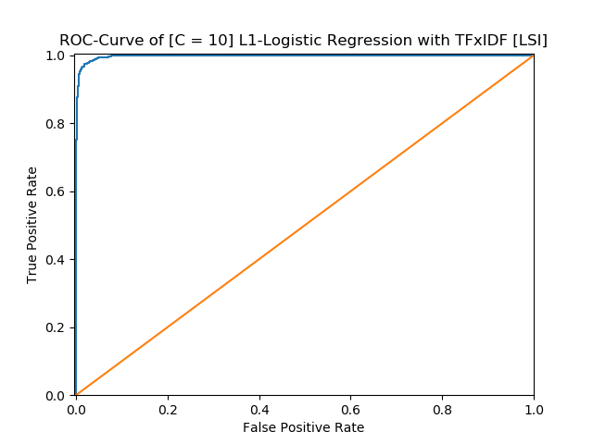

************************************************************
* [C = 10] L1-Logistic Regression with TFxIDF [LSI]
************************************************************
Precision Recall Accuracy
Computer technology 0.9817 0.9654 0.9740
Recreational activity 0.9666 0.9824 0.9740
Average 0.9739 0.9742 0.9740
------------------------------------------------------------
TP FP FN TN
Computer technology 1506 28 54 1562
Recreational activity 1562 54 28 1506

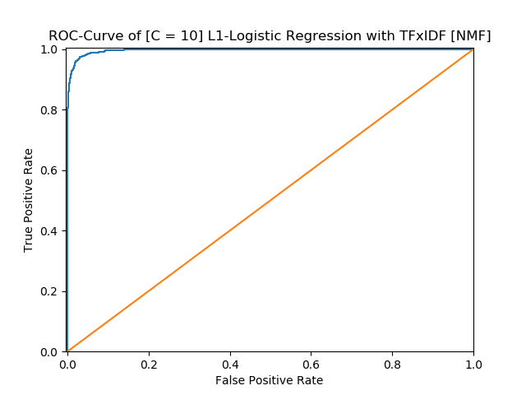

************************************************************
* [C = 10] L1-Logistic Regression with TFxIDF [NMF]
************************************************************
Precision Recall Accuracy
Computer technology 0.9790 0.9551 0.9676
Recreational activity 0.9570 0.9799 0.9676
Average 0.9675 0.9680 0.9676
------------------------------------------------------------
TP FP FN TN
Computer technology 1490 32 70 1558
Recreational activity 1558 70 32 1490

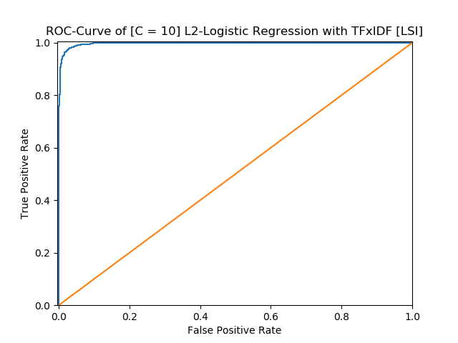

************************************************************
* [C = 10] L2-Logistic Regression with TFxIDF [LSI]
************************************************************
Precision Recall Accuracy
Computer technology 0.9817 0.9635 0.9730
Recreational activity 0.9648 0.9824 0.9730
Average 0.9729 0.9733 0.9730
------------------------------------------------------------
TP FP FN TN
Computer technology 1503 28 57 1562
Recreational activity 1562 57 28 1503

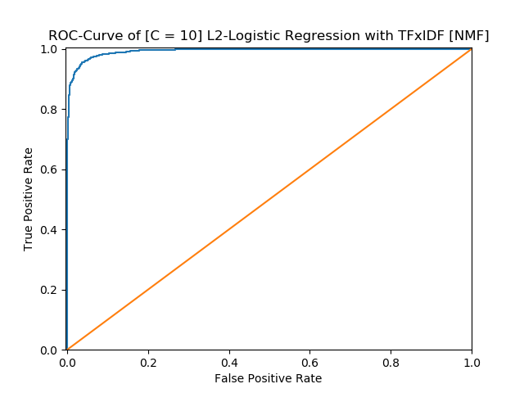

************************************************************
* [C = 10] L2-Logistic Regression with TFxIDF [NMF]
************************************************************
Precision Recall Accuracy
Computer technology 0.9659 0.9455 0.9565
Recreational activity 0.9476 0.9673 0.9565
Average 0.9564 0.9568 0.9565
------------------------------------------------------------
TP FP FN TN
Computer technology 1475 52 85 1538
Recreational activity 1538 85 52 1475

5
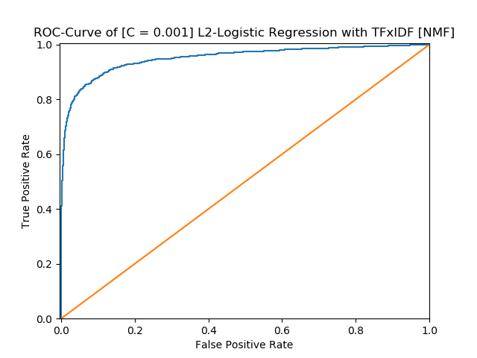

************************************************************
* [C = 0.001] L1-Logistic Regression with TFxIDF [LSI]
************************************************************
Precision Recall Accuracy
Computer technology 0.4952 1.0000 0.4952
Recreational activity 0.0000 0.0000 0.4952
Average 0.5000 0.2476 0.4952
------------------------------------------------------------
TP FP FN TN
Computer technology 1560 1590 0 0
Recreational activity 0 0 1590 1560

************************************************************
* [C = 0.001] L1-Logistic Regression with TFxIDF [NMF]
************************************************************
Precision Recall Accuracy
Computer technology 0.4952 1.0000 0.4952
Recreational activity 0.0000 0.0000 0.4952
Average 0.5000 0.2476 0.4952
------------------------------------------------------------
TP FP FN TN
Computer technology 1560 1590 0 0
Recreational activity 0 0 1590 1560

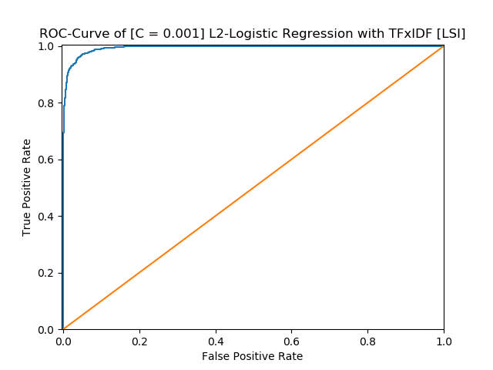

************************************************************
* [C = 0.001] L2-Logistic Regression with TFxIDF [LSI]
************************************************************
Precision Recall Accuracy
Computer technology 1.0000 0.6173 0.8105
Recreational activity 0.7270 1.0000 0.8105
Average 0.8087 0.8635 0.8105
------------------------------------------------------------
TP FP FN TN
Computer technology 963 0 597 1590
Recreational activity 1590 597 0 963

************************************************************
* [C = 0.001] L2-Logistic Regression with TFxIDF [NMF]
************************************************************
Precision Recall Accuracy
Computer technology 0.0000 0.0000 0.5048
Recreational activity 0.5048 1.0000 0.5048
Average 0.5000 0.2524 0.5048
------------------------------------------------------------
TP FP FN TN
Computer technology 0 0 1560 1590
Recreational activity 1590 1560 0 0

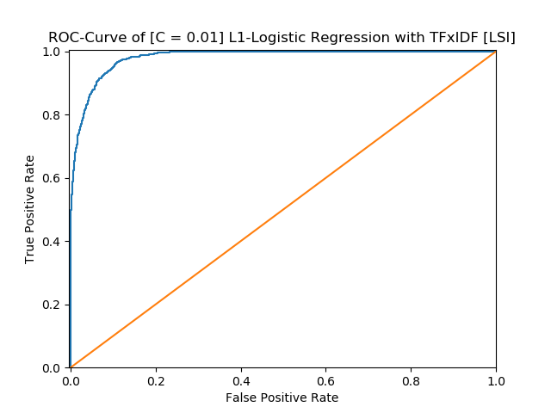

************************************************************
* [C = 0.01] L1-Logistic Regression with TFxIDF [LSI]
************************************************************
Precision Recall Accuracy
Computer technology 0.9367 0.9103 0.9251
Recreational activity 0.9143 0.9396 0.9251
Average 0.9249 0.9255 0.9251
------------------------------------------------------------
TP FP FN TN
Computer technology 1420 96 140 1494
Recreational activity 1494 140 96 1420

************************************************************
* [C = 0.01] L1-Logistic Regression with TFxIDF [NMF]
************************************************************
Precision Recall Accuracy
Computer technology 0.4952 1.0000 0.4952
Recreational activity 0.0000 0.0000 0.4952
Average 0.5000 0.2476 0.4952
------------------------------------------------------------
TP FP FN TN
Computer technology 1560 1590 0 0
Recreational activity 0 0 1590 1560

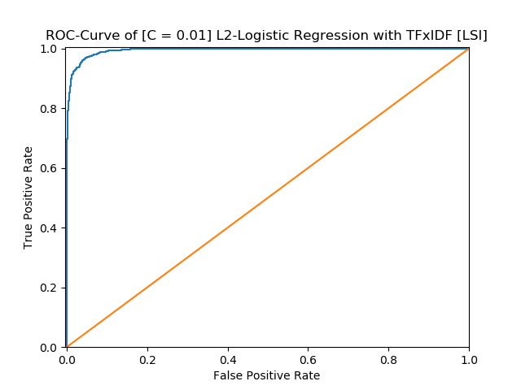

************************************************************
* [C = 0.01] L2-Logistic Regression with TFxIDF [LSI]
************************************************************
Precision Recall Accuracy
Computer technology 0.9881 0.9058 0.9479
Recreational activity 0.9145 0.9893 0.9479
Average 0.9475 0.9513 0.9479
------------------------------------------------------------
TP FP FN TN
Computer technology 1413 17 147 1573
Recreational activity 1573 147 17 1413

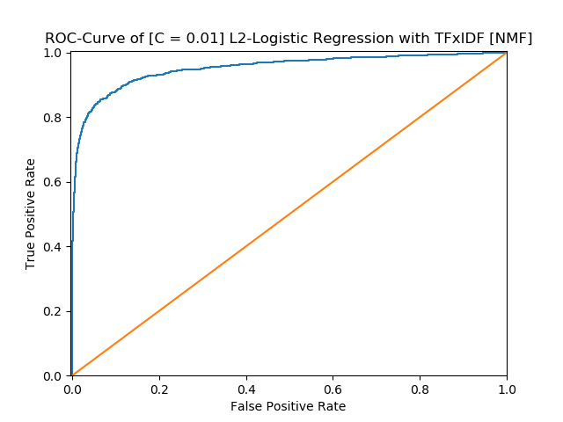

************************************************************
* [C = 0.01] L2-Logistic Regression with TFxIDF [NMF]
************************************************************
Precision Recall Accuracy
Computer technology 0.9503 0.4904 0.7349
Recreational activity 0.6610 0.9748 0.7349
Average 0.7326 0.8056 0.7349
------------------------------------------------------------
TP FP FN TN
Computer technology 765 40 795 1550
Recreational activity 1550 795 40 765

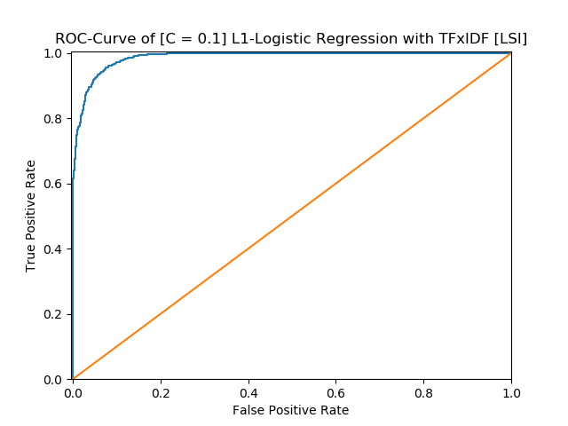

************************************************************
* [C = 0.1] L1-Logistic Regression with TFxIDF [LSI]
************************************************************
Precision Recall Accuracy
Computer technology 0.9523 0.9224 0.9387
Recreational activity 0.9262 0.9547 0.9387
Average 0.9386 0.9393 0.9387
------------------------------------------------------------
TP FP FN TN
Computer technology 1439 72 121 1518
Recreational activity 1518 121 72 1439

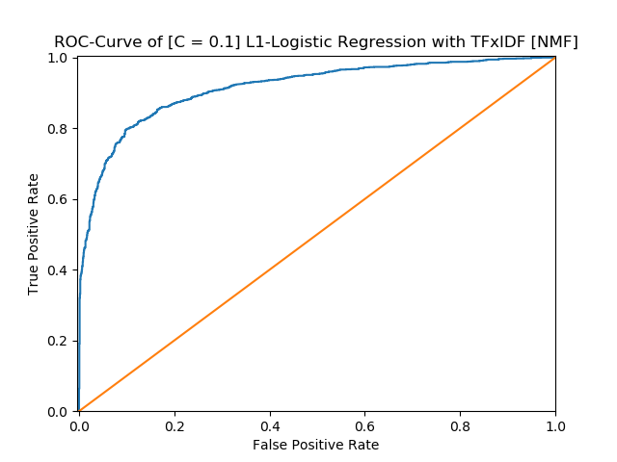

************************************************************
* [C = 0.1] L1-Logistic Regression with TFxIDF [NMF]
************************************************************
Precision Recall Accuracy
Computer technology 0.8189 0.8840 0.8457
Recreational activity 0.8765 0.8082 0.8457
Average 0.8461 0.8477 0.8457
------------------------------------------------------------
TP FP FN TN
Computer technology 1379 305 181 1285
Recreational activity 1285 181 305 1379

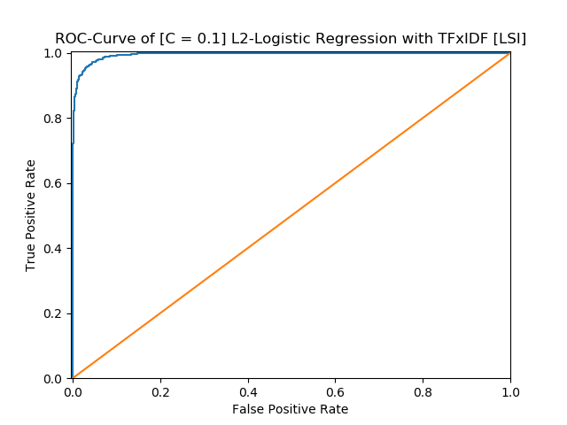

************************************************************
* [C = 0.1] L2-Logistic Regression with TFxIDF [LSI]
************************************************************
Precision Recall Accuracy
Computer technology 0.9755 0.9449 0.9610
Recreational activity 0.9475 0.9767 0.9610
Average 0.9608 0.9615 0.9610
------------------------------------------------------------
TP FP FN TN
Computer technology 1474 37 86 1553
Recreational activity 1553 86 37 1474

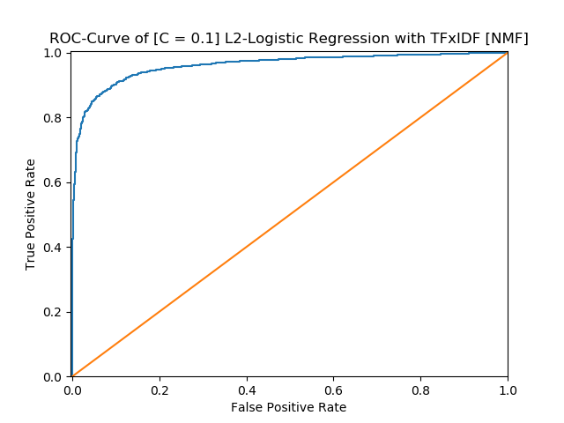

************************************************************
* [C = 0.1] L2-Logistic Regression with TFxIDF [NMF]
************************************************************
Precision Recall Accuracy
Computer technology 0.9113 0.8821 0.8990
Recreational activity 0.8878 0.9157 0.8990
Average 0.8989 0.8995 0.8990
------------------------------------------------------------
TP FP FN TN
Computer technology 1376 134 184 1456
Recreational activity 1456 184 134 1376

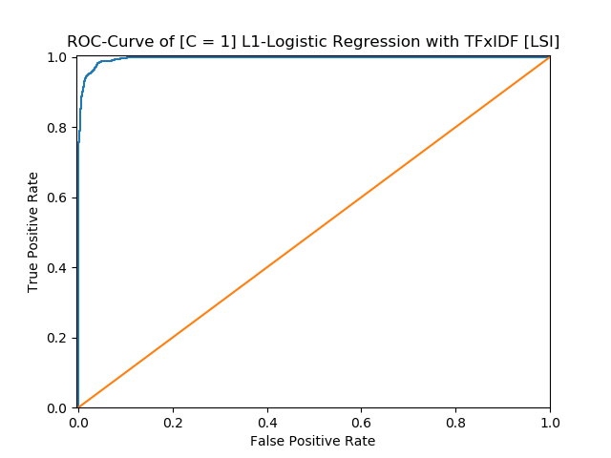

************************************************************
* [C = 1] L1-Logistic Regression with TFxIDF [LSI]
************************************************************
Precision Recall Accuracy
Computer technology 0.9784 0.9596 0.9695
Recreational activity 0.9611 0.9792 0.9695
Average 0.9694 0.9698 0.9695
------------------------------------------------------------
TP FP FN TN
Computer technology 1497 33 63 1557
Recreational activity 1557 63 33 1497

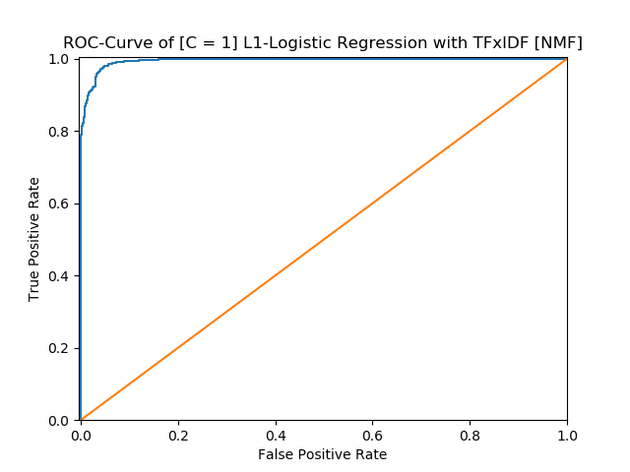

************************************************************
* [C = 1] L1-Logistic Regression with TFxIDF [NMF]
************************************************************
Precision Recall Accuracy
Computer technology 0.9683 0.9603 0.9648
Recreational activity 0.9613 0.9692 0.9648
Average 0.9647 0.9648 0.9648
------------------------------------------------------------
TP FP FN TN
Computer technology 1498 49 62 1541
Recreational activity 1541 62 49 1498

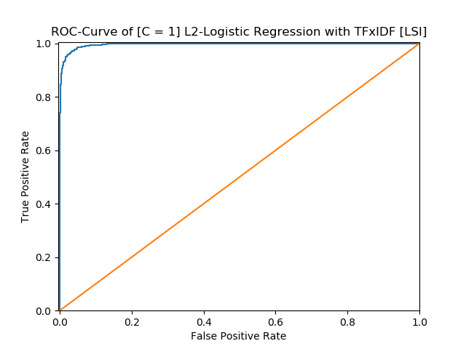

************************************************************
* [C = 1] L2-Logistic Regression with TFxIDF [LSI]
************************************************************
Precision Recall Accuracy
Computer technology 0.9764 0.9551 0.9663
Recreational activity 0.9569 0.9774 0.9663
Average 0.9662 0.9667 0.9663
------------------------------------------------------------
TP FP FN TN
Computer technology 1490 36 70 1554
Recreational activity 1554 70 36 1490

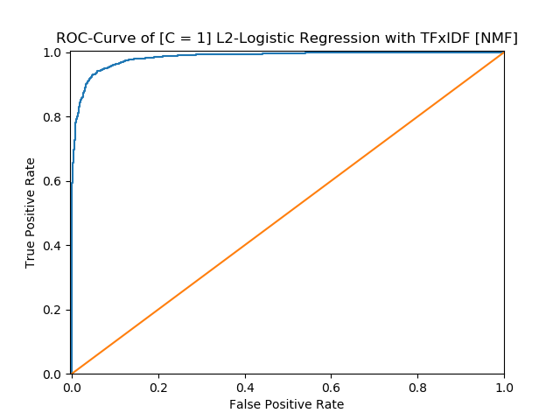

************************************************************
* [C = 1] L2-Logistic Regression with TFxIDF [NMF]
************************************************************
Precision Recall Accuracy
Computer technology 0.9400 0.9346 0.9381
Recreational activity 0.9362 0.9415 0.9381
Average 0.9381 0.9381 0.9381
------------------------------------------------------------
TP FP FN TN
Computer technology 1458 93 102 1497
Recreational activity 1497 102 93 1458

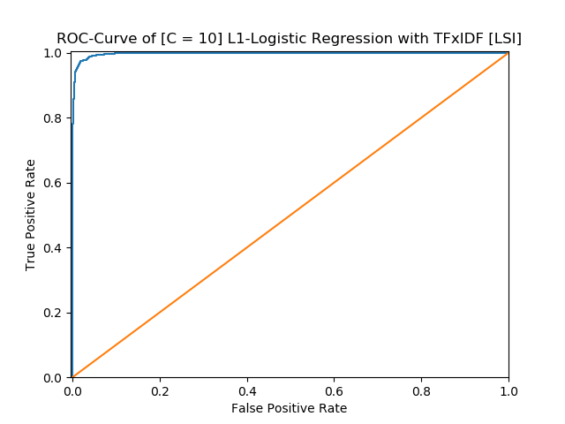

************************************************************
* [C = 10] L1-Logistic Regression with TFxIDF [LSI]
************************************************************
Precision Recall Accuracy
Computer technology 0.9798 0.9654 0.9730
Recreational activity 0.9665 0.9805 0.9730
Average 0.9729 0.9732 0.9730
------------------------------------------------------------
TP FP FN TN
Computer technology 1506 31 54 1559
Recreational activity 1559 54 31 1506

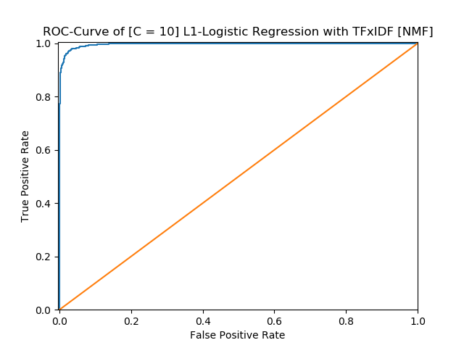

************************************************************
* [C = 10] L1-Logistic Regression with TFxIDF [NMF]
************************************************************
Precision Recall Accuracy
Computer technology 0.9810 0.9603 0.9711
Recreational activity 0.9618 0.9818 0.9711
Average 0.9710 0.9714 0.9711
------------------------------------------------------------
TP FP FN TN
Computer technology 1498 29 62 1561
Recreational activity 1561 62 29 1498

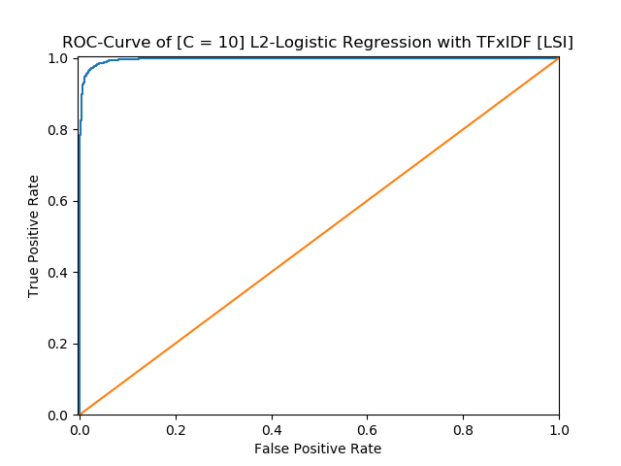

************************************************************
* [C = 10] L2-Logistic Regression with TFxIDF [LSI]
************************************************************
Precision Recall Accuracy
Computer technology 0.9811 0.9647 0.9733
Recreational activity 0.9660 0.9818 0.9733
Average 0.9733 0.9735 0.9733
------------------------------------------------------------
TP FP FN TN
Computer technology 1505 29 55 1561
Recreational activity 1561 55 29 1505

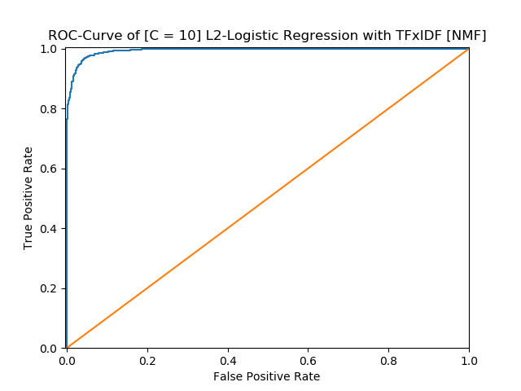

************************************************************
* [C = 10] L2-Logistic Regression with TFxIDF [NMF]
************************************************************
Precision Recall Accuracy
Computer technology 0.9711 0.9487 0.9606
Recreational activity 0.9508 0.9723 0.9606
Average 0.9605 0.9610 0.9606
------------------------------------------------------------
TP FP FN TN
Computer technology 1480 44 80 1546
Recreational activity 1546 80 44 1480
------------------------------------------------------------

10. In this part, we aim to perform Naïve Bayes classification and multiclass SVM classification (with both One VS One and One VS the rest methods described above) and report the confusion matrix and calculate the accuracy, recall
and precision of your classifiers

* Multinomial NaiveBayes with TFIDF threshold is 2 [LSI]
************************************************************
Precision Recall Accuracy
comp.sys.ibm.pc.hardware 0.7717 0.6811 0.8696
comp.sys.mac.hardware 0.8177 0.7688 0.9010
misc.forsale 0.7131 0.8667 0.8799
soc.religion.christian 0.9765 0.9397 0.9789
Average 0.8141 0.8197 0.9073
------------------------------------------------------------
TP FP FN TN
comp.sys.ibm.pc.hardware 267 79 125 1094
comp.sys.mac.hardware 296 66 89 1114
misc.forsale 338 136 52 1039
soc.religion.christian 374 9 24 1158
------------------------------------------------------------
************************************************************
* Multinomial NaiveBayes with TFIDF threshold is 2 [NMF]
************************************************************
Precision Recall Accuracy
comp.sys.ibm.pc.hardware 0.8054 0.7602 0.8939
comp.sys.mac.hardware 0.8226 0.7948 0.9073
misc.forsale 0.8000 0.8615 0.9118
soc.religion.christian 0.9752 0.9874 0.9904
Average 0.8510 0.8508 0.9259
------------------------------------------------------------
TP FP FN TN
comp.sys.ibm.pc.hardware 298 72 94 1101
comp.sys.mac.hardware 306 66 79 1114
misc.forsale 336 84 54 1091
soc.religion.christian 393 10 5 1157

************************************************************
* Multinomial NaiveBayes with TFIDF threshold is 5 [LSI]
************************************************************
Precision Recall Accuracy
comp.sys.ibm.pc.hardware 0.7237 0.8087 0.8748
comp.sys.mac.hardware 0.9022 0.6468 0.8958
misc.forsale 0.8739 0.7821 0.9176
soc.religion.christian 0.7928 1.0000 0.9335
Average 0.8094 0.8232 0.9054
------------------------------------------------------------
TP FP FN TN
comp.sys.ibm.pc.hardware 317 121 75 1052
comp.sys.mac.hardware 249 27 136 1153
misc.forsale 305 44 85 1131
soc.religion.christian 398 104 0 1063
------------------------------------------------------------
************************************************************
* Multinomial NaiveBayes with TFIDF threshold is 5 [NMF]
************************************************************
Precision Recall Accuracy
comp.sys.ibm.pc.hardware 0.7558 0.7500 0.8767
comp.sys.mac.hardware 0.7836 0.7714 0.8914
misc.forsale 0.8321 0.8513 0.9201
soc.religion.christian 0.9824 0.9824 0.9911
Average 0.8388 0.8385 0.9198
------------------------------------------------------------
TP FP FN TN
comp.sys.ibm.pc.hardware 294 95 98 1078
comp.sys.mac.hardware 297 82 88 1098
misc.forsale 332 67 58 1108
soc.religion.christian 391 7 7 1160

SVM

************************************************************
* Multy SVM ovo with TFIDF threshold is 5 [LSI]
************************************************************
Precision Recall Accuracy
comp.sys.ibm.pc.hardware 0.7815 0.8393 0.9010
comp.sys.mac.hardware 0.8497 0.8078 0.9176
misc.forsale 0.9415 0.7846 0.9342
soc.religion.christian 0.8764 0.9975 0.9636
Average 0.8573 0.8623 0.9291
------------------------------------------------------------
TP FP FN TN
comp.sys.ibm.pc.hardware 329 92 63 1081
comp.sys.mac.hardware 311 55 74 1125
misc.forsale 306 19 84 1156
soc.religion.christian 397 56 1 1111
------------------------------------------------------------
************************************************************
* Multy SVM ovo with TFIDF threshold is 5 [NMF]
************************************************************
Precision Recall Accuracy
comp.sys.ibm.pc.hardware 0.5883 0.9005 0.8173
comp.sys.mac.hardware 0.8517 0.6416 0.8843
misc.forsale 0.9649 0.7051 0.9201
soc.religion.christian 0.9769 0.9573 0.9834
Average 0.8011 0.8455 0.9013
------------------------------------------------------------
TP FP FN TN
comp.sys.ibm.pc.hardware 353 247 39 926
comp.sys.mac.hardware 247 43 138 1137
misc.forsale 275 10 115 1165
soc.religion.christian 381 9 17 1158
------------------------------------------------------------
************************************************************
* Multy SVM ovr with TFIDF threshold is 5 [LSI]
************************************************************
Precision Recall Accuracy
comp.sys.ibm.pc.hardware 0.7815 0.8393 0.9010
comp.sys.mac.hardware 0.8497 0.8078 0.9176
misc.forsale 0.9415 0.7846 0.9342
soc.religion.christian 0.8764 0.9975 0.9636
Average 0.8573 0.8623 0.9291
------------------------------------------------------------
TP FP FN TN
comp.sys.ibm.pc.hardware 329 92 63 1081
comp.sys.mac.hardware 311 55 74 1125
misc.forsale 306 19 84 1156
soc.religion.christian 397 56 1 1111
------------------------------------------------------------
************************************************************
* Multy SVM ovr with TFIDF threshold is 5 [NMF]
************************************************************
Precision Recall Accuracy
comp.sys.ibm.pc.hardware 0.5883 0.9005 0.8173
comp.sys.mac.hardware 0.8517 0.6416 0.8843
misc.forsale 0.9649 0.7051 0.9201
soc.religion.christian 0.9769 0.9573 0.9834
Average 0.8011 0.8455 0.9013
------------------------------------------------------------
TP FP FN TN
comp.sys.ibm.pc.hardware 353 247 39 926
comp.sys.mac.hardware 247 43 138 1137
misc.forsale 275 10 115 1165
soc.religion.christian 381 9 17 1158

************************************************************
* Multy SVM ovo with TFIDF threshold is 2 [LSI]
************************************************************
Precision Recall Accuracy
comp.sys.ibm.pc.hardware 0.8686 0.6071 0.8786
comp.sys.mac.hardware 0.7445 0.8857 0.8971
misc.forsale 0.7773 0.8949 0.9099
soc.religion.christian 0.9870 0.9523 0.9847
Average 0.8350 0.8444 0.9176
------------------------------------------------------------
TP FP FN TN
comp.sys.ibm.pc.hardware 238 36 154 1137
comp.sys.mac.hardware 341 117 44 1063
misc.forsale 349 100 41 1075
soc.religion.christian 379 5 19 1162
------------------------------------------------------------
************************************************************
* Multy SVM ovo with TFIDF threshold is 2 [NMF]
************************************************************
Precision Recall Accuracy
comp.sys.ibm.pc.hardware 0.6313 0.8954 0.8428
comp.sys.mac.hardware 0.8338 0.7039 0.8927
misc.forsale 0.9630 0.7333 0.9265
soc.religion.christian 0.9897 0.9623 0.9879
Average 0.8237 0.8544 0.9125
------------------------------------------------------------
TP FP FN TN
comp.sys.ibm.pc.hardware 351 205 41 968
comp.sys.mac.hardware 271 54 114 1126
misc.forsale 286 11 104 1164
soc.religion.christian 383 4 15 1163
------------------------------------------------------------
************************************************************
* Multy SVM ovr with TFIDF threshold is 2 [LSI]
************************************************************
Precision Recall Accuracy
comp.sys.ibm.pc.hardware 0.8686 0.6071 0.8786
comp.sys.mac.hardware 0.7445 0.8857 0.8971
misc.forsale 0.7773 0.8949 0.9099
soc.religion.christian 0.9870 0.9523 0.9847
Average 0.8350 0.8444 0.9176
------------------------------------------------------------
TP FP FN TN
comp.sys.ibm.pc.hardware 238 36 154 1137
comp.sys.mac.hardware 341 117 44 1063
misc.forsale 349 100 41 1075
soc.religion.christian 379 5 19 1162
------------------------------------------------------------
************************************************************
* Multy SVM ovr with TFIDF threshold is 2 [NMF]
************************************************************
Precision Recall Accuracy
comp.sys.ibm.pc.hardware 0.6313 0.8954 0.8428
comp.sys.mac.hardware 0.8338 0.7039 0.8927
misc.forsale 0.9630 0.7333 0.9265
soc.religion.christian 0.9897 0.9623 0.9879
Average 0.8237 0.8544 0.9125
------------------------------------------------------------
TP FP FN TN
comp.sys.ibm.pc.hardware 351 205 41 968
comp.sys.mac.hardware 271 54 114 1126
misc.forsale 286 11 104 1164
soc.religion.christian 383 4 15 1163
------------------------------------------------------------

